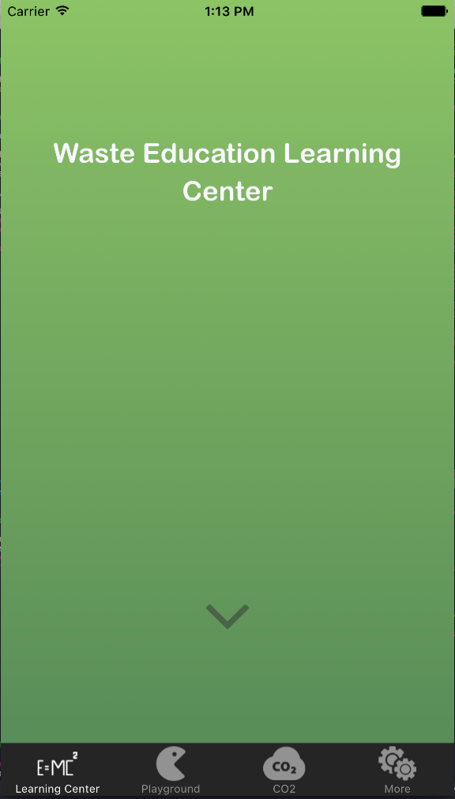

Waste Education  
Learning Centre

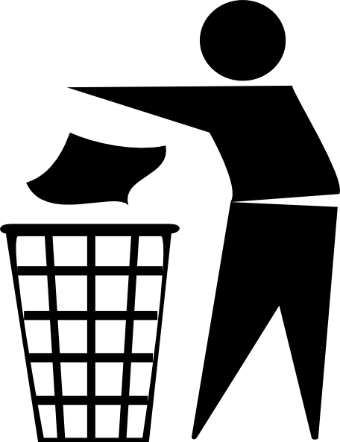

Space the text out like this and add the image

I think the colour scheme should be restricted to black, white, grey and the standard bin colours:

**RED**

**YELLOW**

**GREEN**

**ROYAL BLUE**

Black & white images might sound boring but it stands out and is very easy to read.

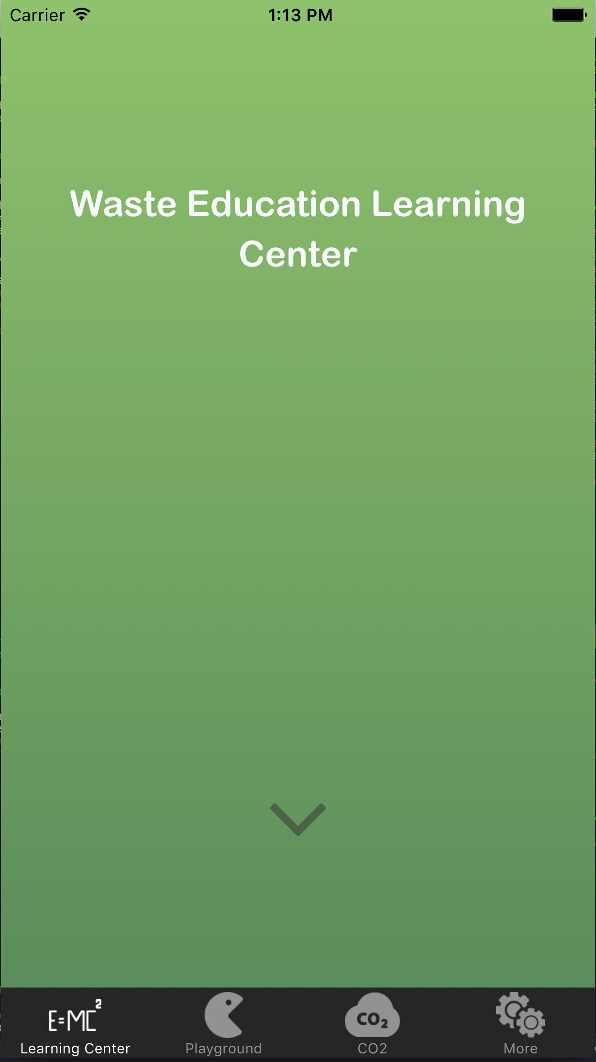

Next page

What a Waste

More than 506 tonnes of waste and 243 tonnes of recycling is disposed of from the North Terrace campus every year.

Combined, this weighs as much as five full-sized blue whales!

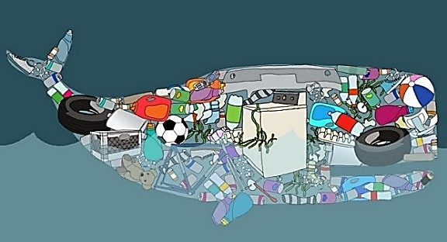

We must all make an effort to dispose of waste and recycling correctly.



Next page

Waste Generated in the Hub (2015)

Waste Generated in Hub Central in 2015

Can the games be icons instead of blocks?

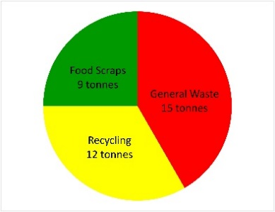

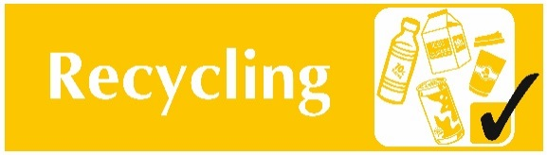

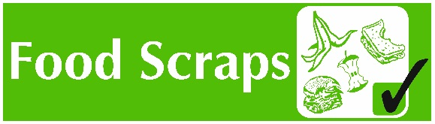

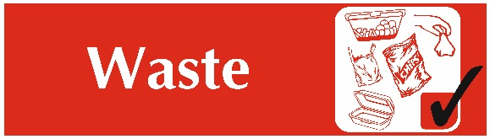



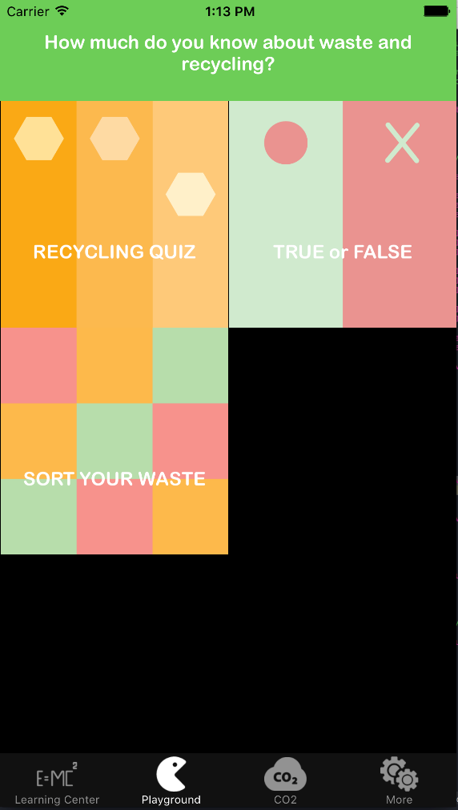

How much do you know about  
waste and recycling?

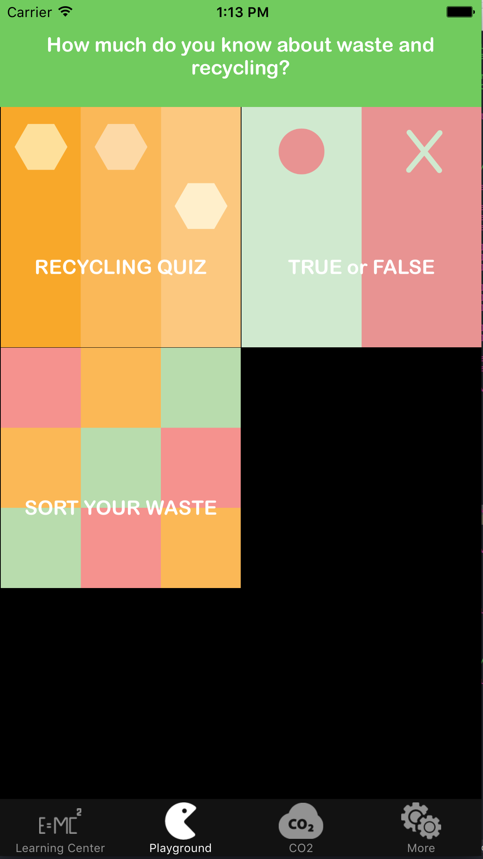

CO2-e page

Australians generate more than 8 million tonnes of food waste annually and most of it ends up in landfill.

Once in the ground, food breaks down slowly due to a lack of oxygen and emits potent greenhouse gases.

How does this compare to the emissions produced by the average household through electricity use?

Use our calculator to find out.

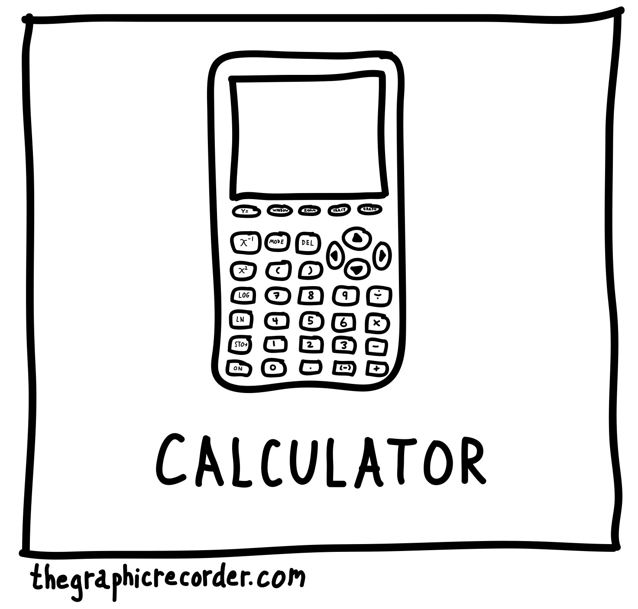

Calculate Emissions from Waste



**Page 2**

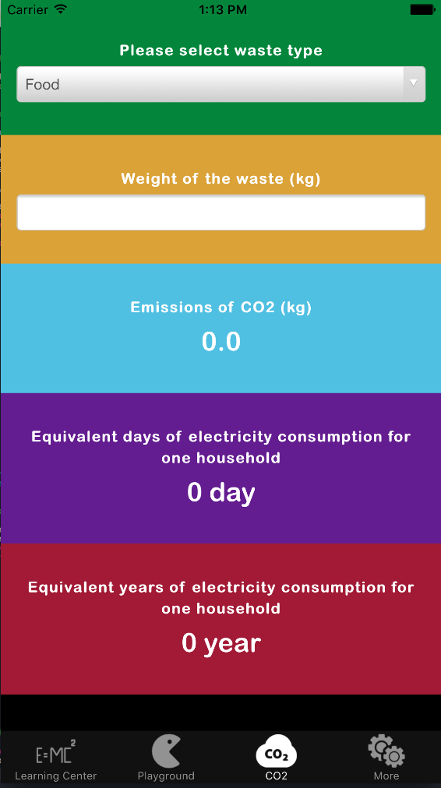

Select waste type

Amount of waste (kg)



CO2-e emissions generated   
if disposed of in landfill  
  
0.0 kg

Equivalent days of electricity   
consumption for one household  
  
0 day

This should be CO2-e

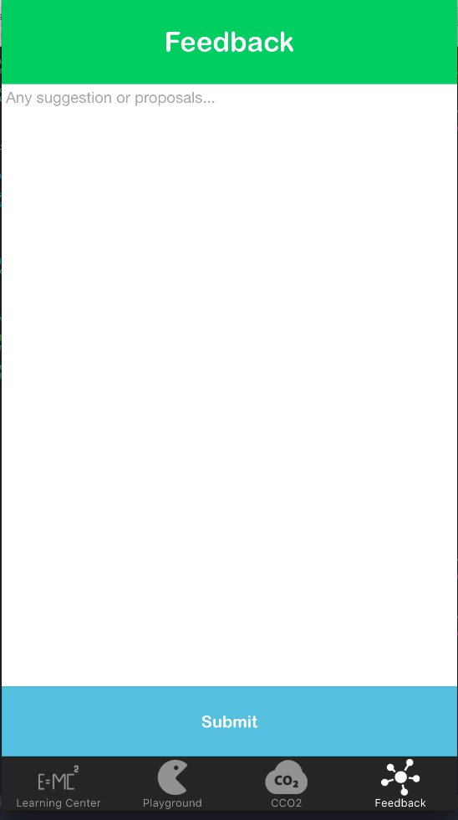



Feedback

We welcome your feedback, comments or questions.

Submit Feedback

About Us page

This App was created by University of Adelaide student Yue Zhou, in collaboration with Ecoversity and the School of Computer Science.

For more information about waste and recycling on campus, check out the Ecoversity website [www.adelaide.edu.au/ecoversity](http://www.adelaide.edu.au/ecoversity) or find us on facebook.

Can you also change the Submit bar so that it looks more like a button that people have to press? e.g.

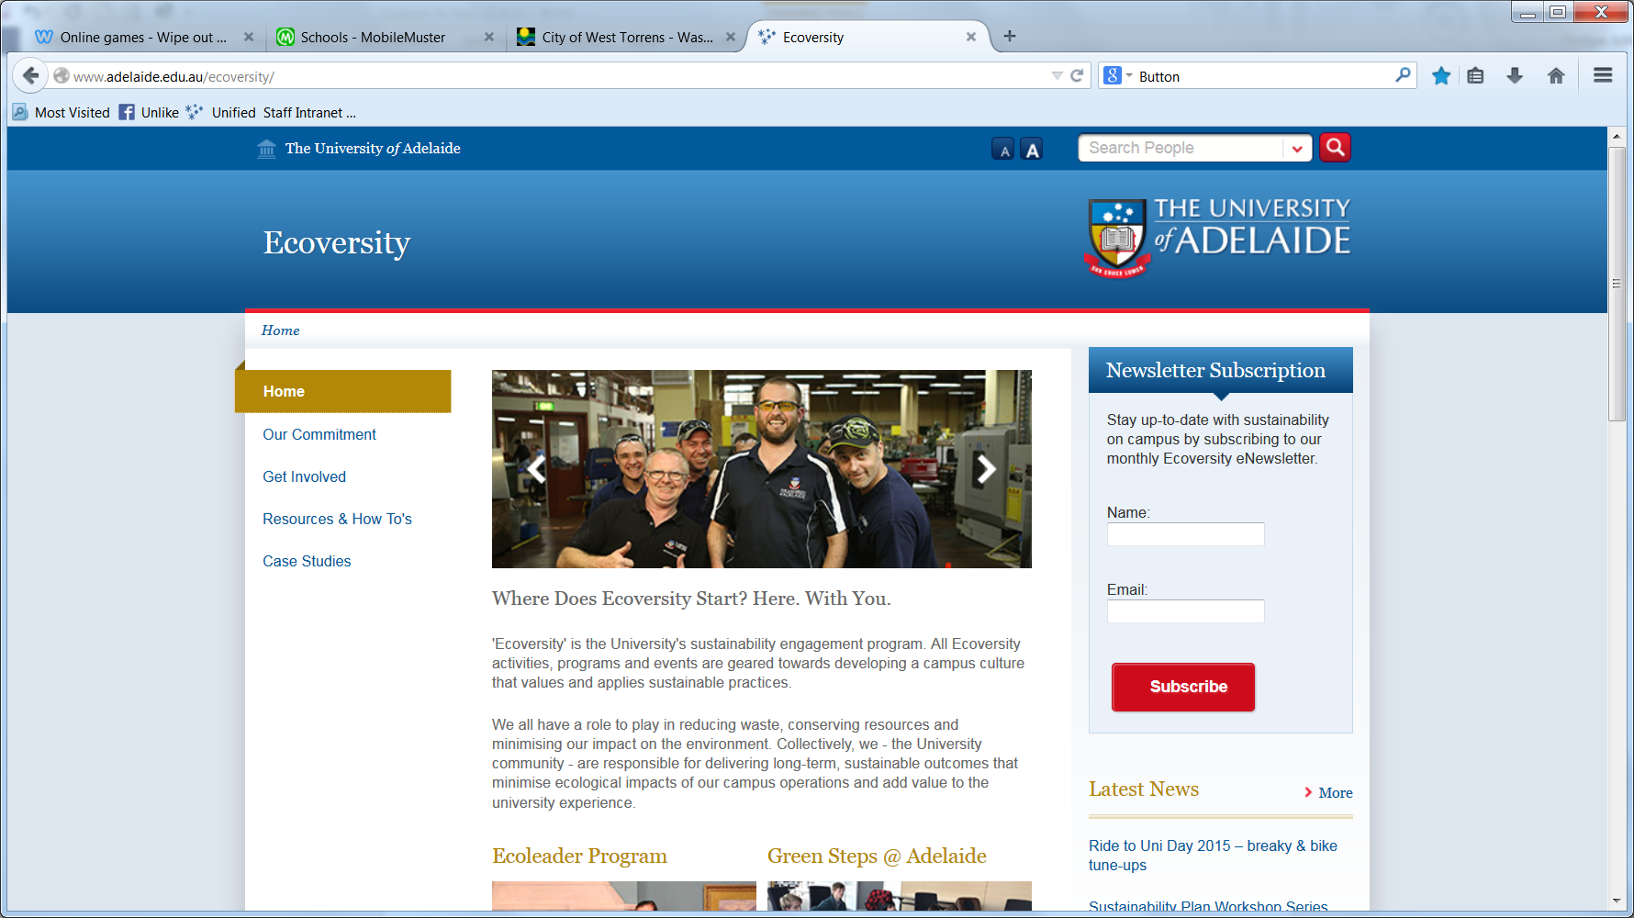

Could you use a digital font to display the results?

<http://www.1001fonts.com/calculator-fonts.html>

Playground page

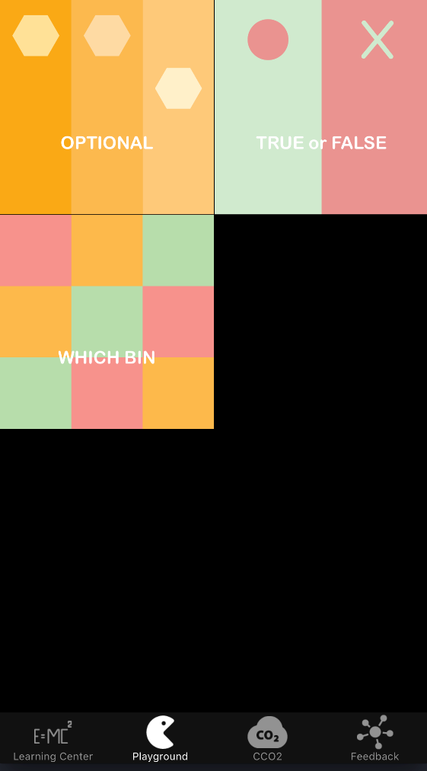

Please add to the top of the page above the boxes:

**How much do you know about waste and recycling?**

Play to find out.

Please change the name of the games to:

* RECYCLING QUIZ (instead of Optional)
* TRUE or FALSE
* SORT YOUR WASTE (instead of Which Bin)

About Us

This App has been created to help teach correct recycling practices in order to increase recycling rates and decrease volumes of waste to landfill.